LAB 4: Modeling a Robot-Arm Link in Simscape

Course Number | MENG 3020
Course Title | System Modeling & Simulation
Semester/Year | Fall 2025

Lab/Tutorial Report No. | Lab 4
Report Title | Modeling a Robot-Arm Link in Simscape
Section No. | 0NA
Group No. | N/A
Submission Date | November 2nd, 2025
Due Date | November 2nd, 2025

Student Name | Signature* | Total Mark
Michael McCorkell |  | / 50

* By signing above, you attest that you have contributed to this submission and confirm that all work you have contributed to this submission is your work. Any suspicion of copying or plagiarism in this work will result in an investigation of Academic Misconduct and may result in a ZERO on the work or possibly more severe penalties.
https://academic-regulations.humber.ca/2021-2022/17.0-ACADEMIC-MISCONDUCT

LAB 4 Grading Sheet

Student First Name:  Michael | Student Last Name:  McCorkell
Part A: Modeling an Armature Controlled DC Motor |  | /5
Part B: Simscape Model of DC Motor and Geared System |  | /10
Part C: Simscape Model of Dynamics of a Robot Arm Joint |  | /10
Part D: Position Control of the Robot Arm |  | /5
Post Lab Assignment |  | /15
General Formatting: Clarity, Writing style, Grammar, Spelling, Layout of the report |  | /5
Total Mark |  | /50

LAB 4: Modeling a Robot-Arm Link in Simscape

OBJECTIVES
- To learn how to simulate multi-physical systems in Simscape
- To acquire the results and validate them based on the system characteristics
- To understand concept of control system and negative feedback

INTRODUCTION
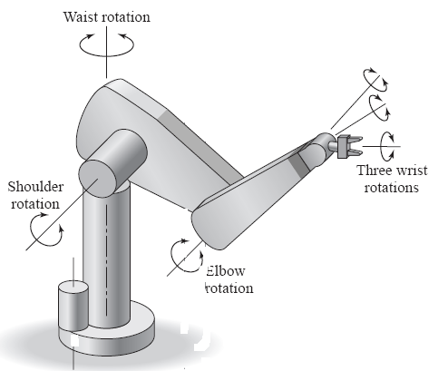
Simscape extends the capabilities of Simulink by providing tools for modeling and simulation of multi-domain physical systems, such as those with mechanical, hydraulic, and electrical components. In this lab project, you will understand how to utilize Simscape to construct models of electrical and mechanical systems. Shown below is a robot arm that has six joints. You will develop a model of one of those joints. A single link of a robot arm is shown in Figure 1b.

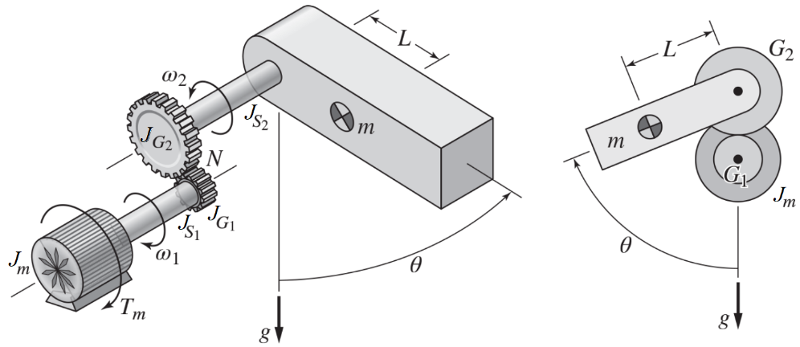

(a) Robot arm (b) A robot-arm link

Figure 1: Robot arm and a link

The goal is to develop a model and a controller to ensure that the angle $θ$ of the robot arm joint shown below tracks a prescribed profile. The joint is actuated by a DC motor that drives an arm of mass $m$ through a gear pair.
The arm mass center is located a distance $L$ from the rotational axis of the joint. The weight $mg$ exerts a torque 𝑚𝑔𝐿sin𝜃 that acts in the negative 𝜃 direction. The values of $m$ and $L$ depend on the payload being carried in the hand and thus can be different for each application.
Since a DC motor consists of electrical and mechanical subsystems, we will start with analysis of DC motor and its characteristics (Part A).
We will then build a model of the dynamics of a rotational mechanical system containing gears, such as the robot arm joint (Part B).
Then we will add the gravity torque 𝑚𝑔𝐿sin𝜃 to complete the model of the arm’s dynamics (Part C).
Finally, we will design a position controller for the system (Part D).

Part A: Modeling an Armature Controlled DC Motor
We start with the Simscape model of a DC Motor.
- Open a new Simulink model page. Find and place the following elements and components from the Simulink Library Browser.
  - Simscape > Foundation Library > Electrical > Electrical Sources > DC Voltage Source
  - Simscape > Electrical > Electromechanical > Brushed Motors > DC Motor
  - Simscape > Foundation Library > Electrical > Electrical Elements > Electrical Reference
  - Simscape > Foundation Library > Electrical > Electrical Sensors > Current Sensor
  - Simscape > Foundation Library > Mechanical > Mechanical Sensors > Ideal Rotational Motion Sensor
  - Simscape > Foundation Library > Mechanical > Rotational Elements > Mechanical Rotational Reference
  - Simscape > Utilities > PS-Simulink Converter
  - Simscape > Utilities > Solver Configuration
  - Simulink > Sinks > Scope

- Arrange and connect the blocks as shown:
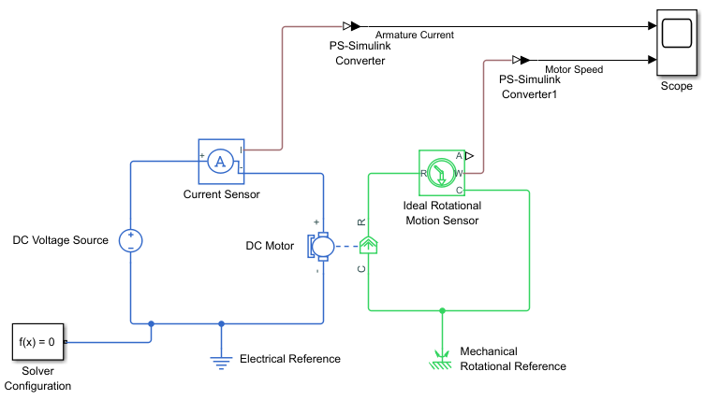

- Provide your final Simscape model diagram for Part A below:
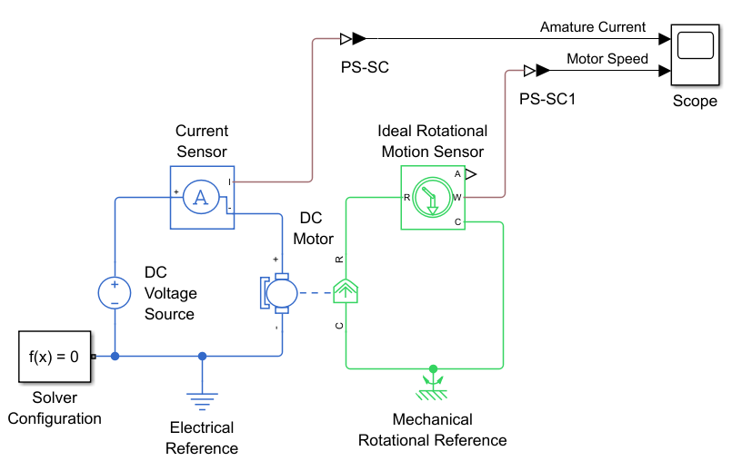

- Enter the following parameter values for DC Voltage Source, DC Motor and PS-Simulink Converter1 blocks:
- DC Voltage Source:
Constant Voltage = 24 V
- DC Motor:
Armature resistance = 20 Ohm, Armature inductance = 100 mH, Torque constant = 0.4 N.m/A
Rotor inertia = 0.005 kg.m², Rotor damping = 0.001 Nm/(rad/s), Initial rotor speed = 0 rpm
- PS-Simulink Converter1:
Output Signal Unit = rpm
- Click on the Model Settings icon in the MODELING tab to open the Configuration Parameters window. Click on the Solver drop down menu and select the ode23t solver. Then click OK.
- Save the model file as Lab4_PartA.slx. Set the simulation Stop Time to 10sec and Run the simulation. Open the Scope block. You will see the armature current in ampere and the motor speed in rpm. Provide the graphs below:
Armature Current (A) Motor Speed (rpm)
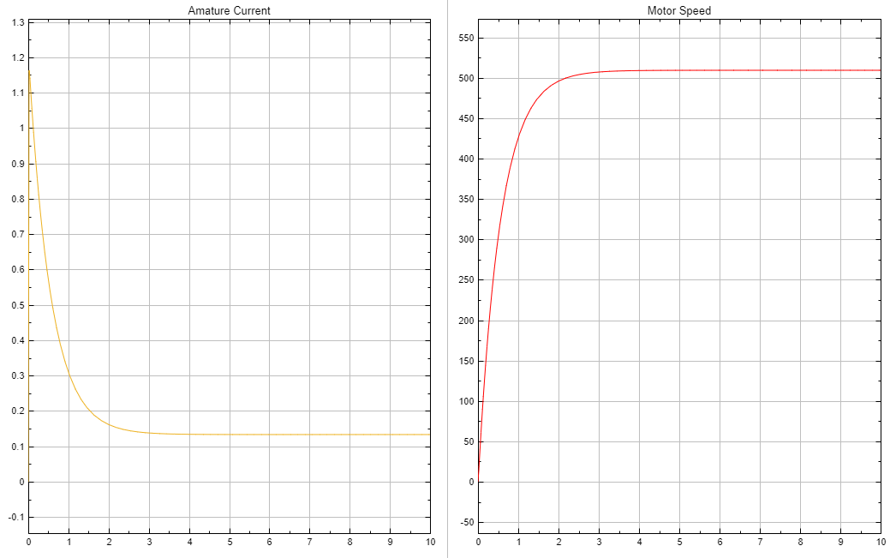

- Activate the Cursor Measurements of Scope and measure the steady-state current and speed values from the plot and enter the values in Table 1.
Since there is no load connected to the motor, the measured values are called no-load current and no-load speed. The no-load current is required to provide a torque to cancel the motor damping torque.
Table 1
Armature Current (A) | Motor Speed (rpm)
0.1333 A | 509.29 rpm

Part B: Simscape Model of DC Motor and Geared System
- The figure below shows a representation of a rotational system containing a DC motor and a gear pair. The inertias $J_{1}$ and $J_{2}$ represent the elements on the driving side and the driven side, respectively.
$$J_{1}\text{=}J_{S1}\text{+}J_{G1} ∧ J_{2}\text{=}J_{S2}\text{+}J_{G2}$$
The gear ratio is $N\text{=}N_{2}\text{/}N_{1}$.
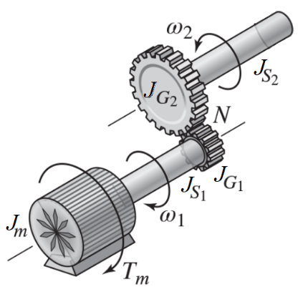

- Modify the model from Part A to construct the Simscape model of the gear pair and the shafts. Find and place the following elements and components from Simulink Browser Library:
- Simscape > Foundation Library > Mechanical > Mechanisms > Gear Box
- Simscape > Foundation Library > Mechanical > Rotational Elements > Inertia
- Simscape > Foundation Library > Mechanical > Mechanical Sensors > Ideal Rotational Motion Sensor
  - Simscape > Utilities > PS-Simulink Converter
  - Simulink > Sinks > Scope

- Arrange and connect the blocks as shown:
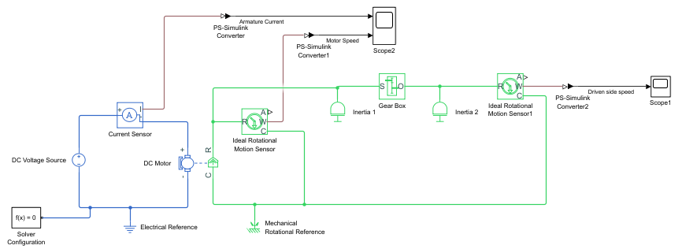

Provide your final Simscape model diagram for Part B below:
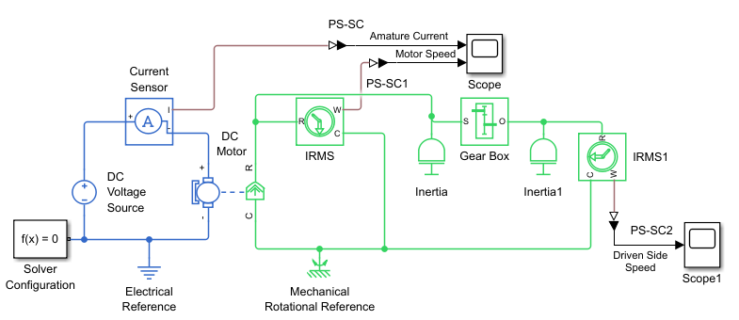

- The Gear Box block contains only one parameter, the gear ratio. Thus, it represents a kinematic constraint only. In particular, the block does not model gear friction or the gear inertias. The former may be captured by a Rotational Friction element, while the latter must be included in the inertias $J_{1}$ and $J_{2}$ connected to the gear box.
- Set the following values for the Inertias and Gear Box:
Drive Side: Inertia 1 → $J_{1}\text{=}J_{S1}\text{+}J_{G1}\text{=}0.025\text{+}0.01\text{=}0.035$ kg$·m^{2}$,
Driven Side: Inertia 2 → $J_{2}\text{=}J_{S2}\text{+}J_{G2}\text{=}0.02\text{+}0.1\text{=}0.12$ kg$·m^{2}$,
Gear Ratio → $N\text{=}\frac{N_{2}}{N_{1}}\text{=}5$
- Set the PS-Simulink Converter2 block Output Signal Unit as rpm.
- Save the model file as Lab4_PartB.slx and Run the simulation for 50 sec.
- Open the two Scope blocks and provide the graphs below:
Armature Current (A) Motor Speed (Drive side) (rpm)
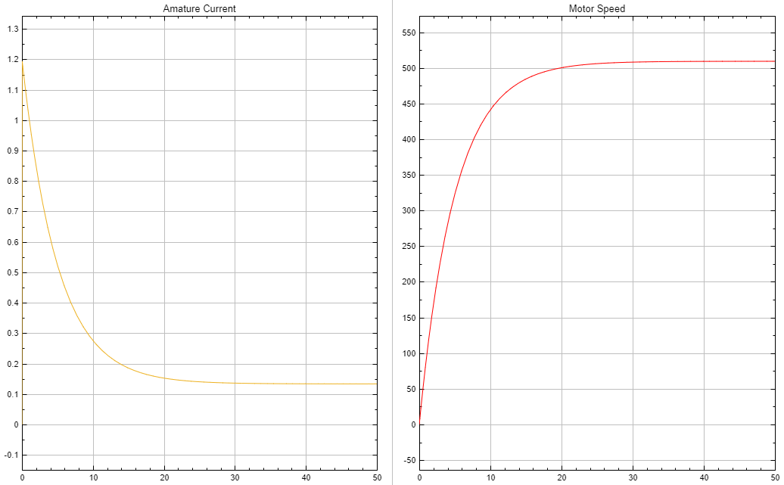

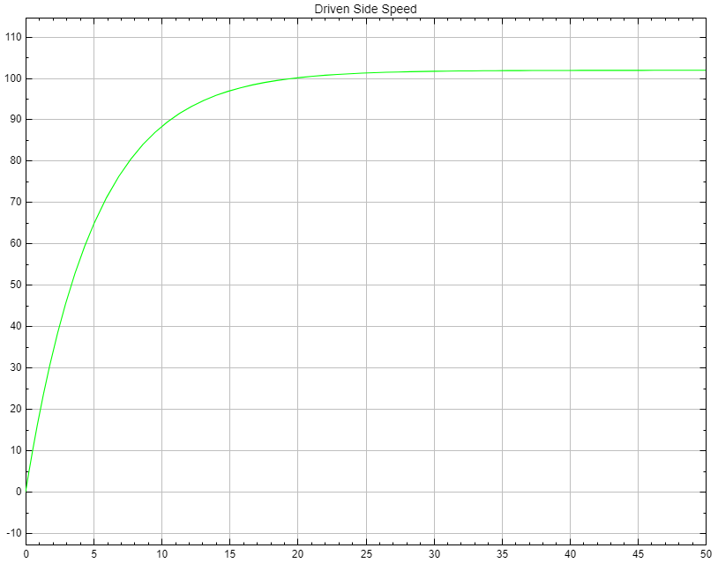
Driven Side Speed (rpm)

- Measure the steady-state current and the steady-state speed values for the drive side and the driven side from the plot and enter the values in Table 2.
Table 2
Armature Current (A) | Drive side Speed (rpm) | Driven side Speed (rpm)
0.1333 A | 509.29 rpm | 101 rpm

- Calculate the ratio of the drive side speed to the driven side speed. Is it consistent with the gear ratio?
$N=\frac{509.29}{101}=5.04$
Yes, the gear ratio, is consistent with the Drive side speed and Driven side speed.

- Compare the motor speed in Step 15 with the obtained graph in Step 6. Explain how additional inertia on the motor shaft affects the speed trajectory. Discuss the time constant of the speed graphs.
Adding additional inertia to the motor shaft increases the total rotational inertia of the system. Since the motor must overcome more inertia, it accelerates more slowly for a given torque. This results in a slower speed trajectory, meaning the motor takes longer to reach its steady-state or final speed. Consequently, the time constant of the speed response increases, because the system’s dynamic response becomes slower — the motor resists changes in speed more due to the higher inertia.

Part C: Simscape Model of Dynamics of a Robot Arm Joint
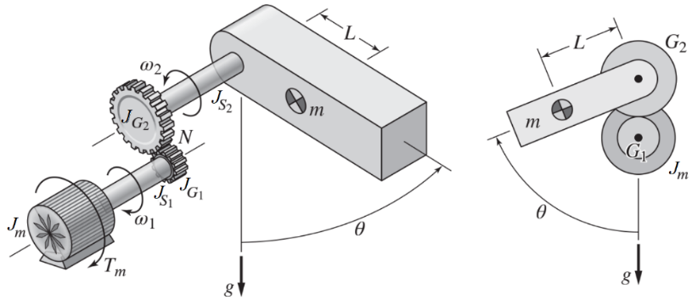
Now we are ready to model the dynamics of the robot arm joint shown below.
To control the motion of the arm we need to have its equation of motion. To obtain the equation of motion in terms of the angle $θ$, the approach is to model the system as a single inertia rotating about the motor shaft with a speed $ω_{1}$.
The equivalent inertia referenced to the motor shaft is: $J_{e}\text{=}J_{m}\text{+}J_{S1}\text{+}J_{G1}\text{+}{\left(\frac{N_{1}}{N_{2}}\right)}^{2}\left(J_{S2}\text{+}J_{G2}\text{+}mL^{2}\right)$
The reflected angle of rotation to the motor shaft is: $\left(\frac{N_{2}}{N_{1}}\right)θ$
The reflected gravitational torque to the motor shaft is: $\left(\frac{N_{1}}{N_{2}}\right)mgLsinθ$
The reflected damping torque to the motor shaft is: $\left(\frac{N_{1}}{N_{2}}\right)B\overset{˙}{θ}$
The equation of motion for this equivalent system on the motor shaft is:
$$J_{e}{\overset{˙}{ω}}_{1}\text{=}T_{m}\text{-}T_{B}\text{-}T_{g} → J_{e}\left(\frac{N_{2}}{N_{1}}\right)\overset{¨}{θ}\text{=}T_{m}\text{-}\frac{N_{1}}{N_{2}}B\overset{˙}{θ}\text{-}\frac{N_{1}}{N_{2}}mgLsinθ$$
The gear ratio is $N\text{=}N_{2}\text{/}N_{1}$
- Insert the following blocks from the library and connect them as shown below:
- Simscape > Foundation Library > Physical Signals > Functions > PS Gain
- Simscape > Foundation Library > Physical Signals > Functions > PS Math Function
- Simscape > Foundation Library > Mechanical > Mechanical Sources > Ideal Torque Source
- Simscape > Foundation Library > Mechanical > Rotational Elements > Rotational Damper
  - Simscape > Utilities > PS-Simulink Converter

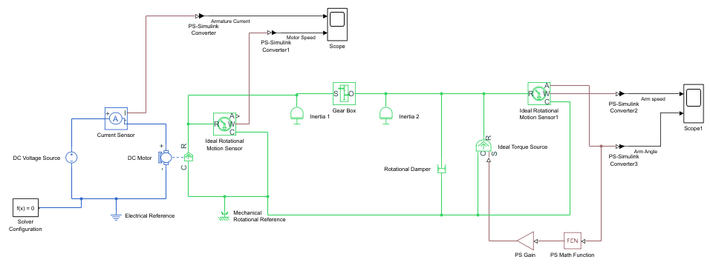
- Let’s examine the new blocks introduced to model the gravitational torque $\text{-}mgLsinθ$.
- The PS Gain block multiplies the input physical signal by a constant called the Gain. Enter $\text{-}m\text{*}g\text{*}L$ in the Block Parameters dialog box. Then assign the values of $m$, $g$, and $L$ in the MATLAB Command Window. Use the following values:
$m \text{=} 4 kg$, $L \text{=} 0.25 m$, $g \text{=} 9.81 m/{s^{2}}$.
- The PS Math Function block applies a mathematical function to the input $u$. Enter $sin(u)$ in its Block Parameter dialog box.
- The Ideal Torque Source block has no parameters. It represents a source capable of providing the torque specified at its physical-signal input port regardless of the angular velocity across its terminals. Since power is the product of torque and angular velocity ($P\text{=}Tω$), the Torque Source is ideal in the sense that it is sufficiently powerful to deliver the specified torque at any speed.
- The Rotational Damper block represents the damping friction effect of the joint arm and the shaft. Set the Damping Coefficient as $2 N.m.s\text{/}rad$.
- Set the PS-Simulink Converter3 block Output Signal Unit as deg.
Provide your final Simscape model diagram for Part C below:
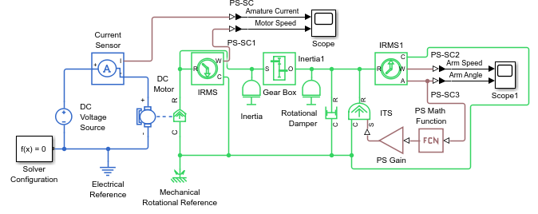

- Save the model file as Lab4_PartC.slx and Run the model using a Stop Time of 10 sec. Provide the arm speed and arm angle graphs below.
Arm speed (rpm) Arm Angle (degrees)
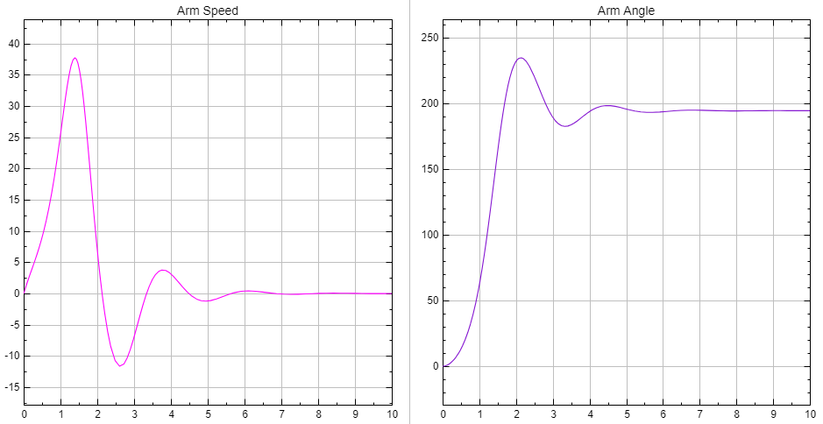

- Measure the steady-state speed and the steady-state angle of the arm from the graph and enter the values in Table3. What is the maximum deviation of the angle from the steady-state value?
Table 3
Arm Speed (rpm) | Arm Angle (deg) | Maximum Deviation of Angle (deg)
0.03 rpm | 194° | 4° deviation

Part D: Position Control of the Robot Arm
- Insert the following blocks from library and connect them as shown below:
- Simscape > Foundation Library > Electrical > Electrical Sources > Controlled Voltage Source
- Simscape > Utilities > Simulink-PS Converter
- Simulink > Continuous > PID Controller
- Simulink > Math Operations > Sum
- Simulink > Discontinuities > Saturation
- Simulink > Sources > Signal Editor
- Simulink > Commonly Used Blocks > Mux
  - Simulink > Sinks > Scope
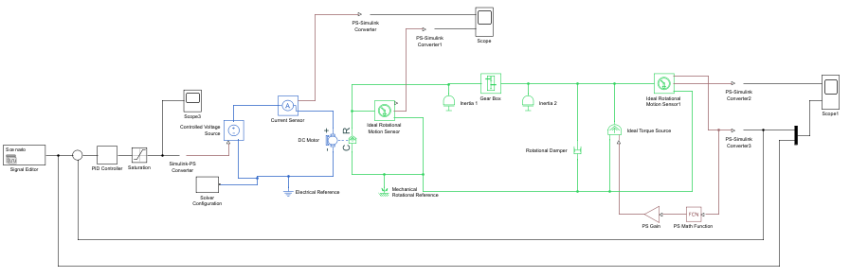
- Enter the following parameter values for Saturation and PID Controller blocks:
- Staurtaion:
Upper limit = 36, Lower limit = -36
- PID Controller:
Proportional = 1, Integral = 2, Derivative = 0.4
NOTE: Design of the PID controller gains is out of scope of this course. It is covered in the Control Systems course.
- The Saturation block limits the applied controlled voltage to the DC motor between the $±36V$. In this range of the voltage the armature current may not exceed $2A$.
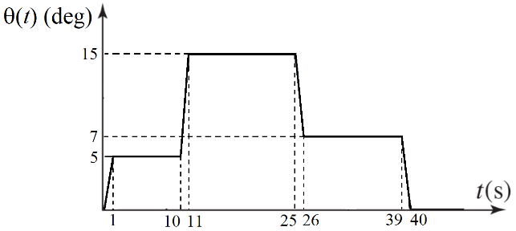
- The Signal Editor block generates the desired values of the robot arm angle in degrees. We use that signal as the reference input of the control system. The objective of control system is to follow the desired angle values.

The following steps show how to set up the Signal Editor block.
- Open the Signal Editor block to define the input function profile based on the Figure 6 as below:
- Click on icon to open the Signal Editor window.
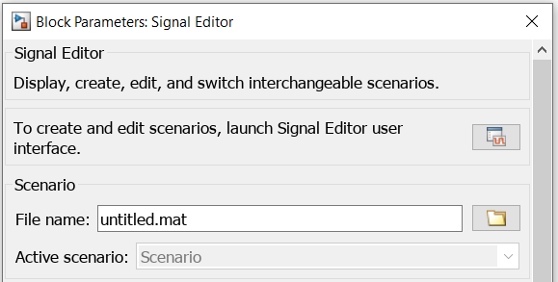

- Click on the small drop-down icon beside the Scenario to see the signal present in it, which is named Signal 1 by default.
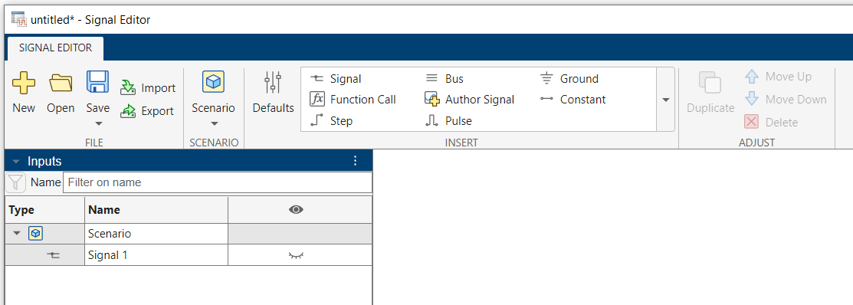

- Double-click on the icon in the right side of the Signal 1 to reveal what is in this signal.
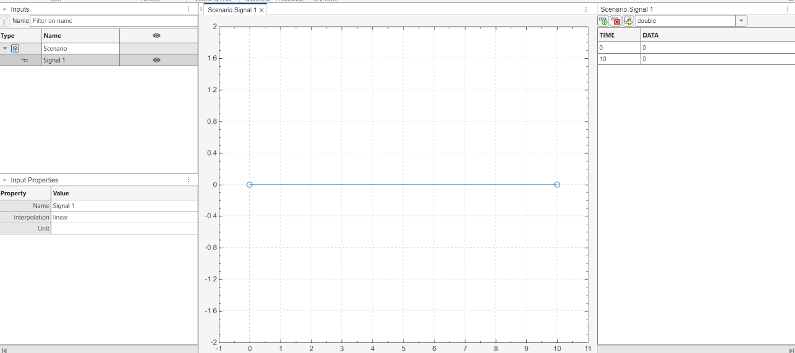
- The signal is blank at the first time. You can add the data for your signal profile by editing the data table in the right side.
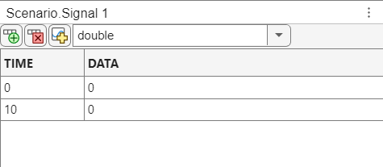
- Click on icon to add more rows to the data table.
- Enter the Time values as [0 1 10 11 25 26 39 40] and Data values as [0 5 5 15 15 7 7 0] based on the desired trajectory.
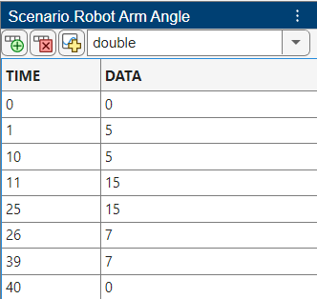

- The robot arm angle values will be created. Click on the signal name and rename the signal as Robot Arm Angle.

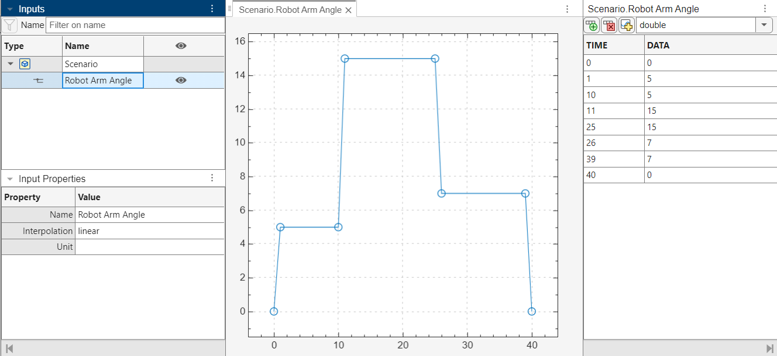

- Save the signal file as Input.mat in the same folder you will save the Simulink file.
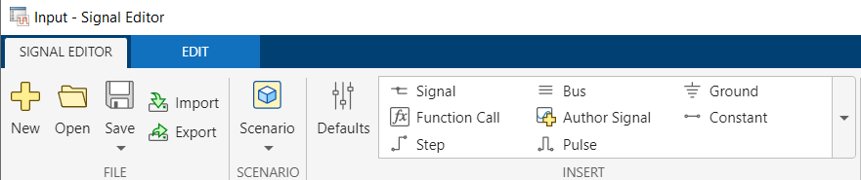

- The signal file name will be appeared in the Block Parameters Dialogue window.
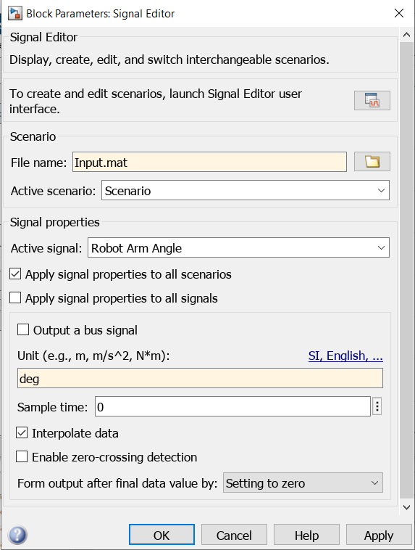

- Set the signal data unit as deg (degrees) in the Unit box.
- Check marks the Interpolate data box.
- Click OK to close the dialogue window.

Provide your final Simscape model diagram for Part D below:
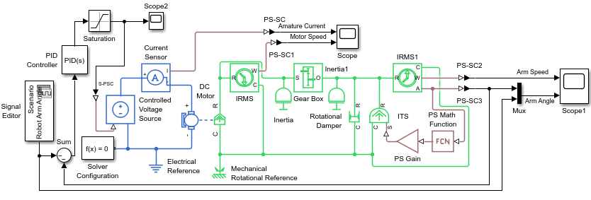

- Save the model file as Lab4_PartD.slx Run the model with a Stop Time of 50 sec. Provide the arm speed and arm angle graphs below.
Arm speed (rpm) Arm Angle (deg)
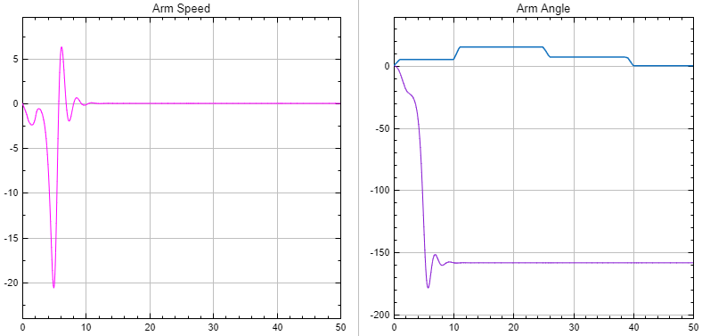

- Observe the applied voltage and the armature current of DC motor. Insert the maximum applied voltage and the maximum armature current values in Table 4?
Table 4
Maximum Voltage (V) | Maximum Current (A)
+36 V | 2.0161 A

Post Lab Assignment
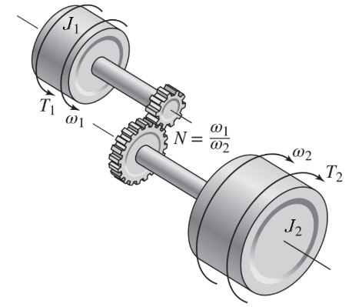
- Consider the spur gears shown in figure below, where $J_{1}\text{=}0.5 kg.m^{2}$ and $J_{2}\text{=}0.5 kg.m^{2}$. Shaft 1 rotates four times faster than shaft 2. The torques are given as $T_{1}\text{=}0.5 N.m$ and $T_{2}\text{=}\text{-}0.3 N.m$. Assume that the gears’ and shafts’ inertias are negligible.

  - Model of the system in Simscape.
  - Connect two motion sensors to measure the angular acceleration in each side.
  - Select an appropriate simulation time and run the simulation.
  - Plot the angular accelerations as two separate graphs in a single Scope with white background.
  - Provide the model diagram, the angular acceleration graphs and the Simscape file.
  - Compare the angular acceleration of side 1 and side 2. Explain the effect of gear ratio on the acceleration.

Hint: You may need the following blocks:
From Simscape Library:
- Inertia
- Gear Box
- Ideal Torque Source
- Solver Configuration
- Mechanical Rotational Reference
- Simulink-PS Converter
- PS-Simulink Converter
- Ideal Rotational Motion Sensor
From Simulink Library:
- Scope
- Constant

Post Lab Assignment

Consider the spur gears shown in figure below, where $J_{1}\text{=}0.5 kg.m^{2}$ and $J_{2}\text{=}0.5 kg.m^{2}$. Shaft 1 rotates four times faster than shaft 2. The torques are given as $T_{1}\text{=}0.5 N.m$ and $T_{2}\text{=}\text{-}0.3 N.m$. Assume that the gears’ and shafts’ inertias are negligible.
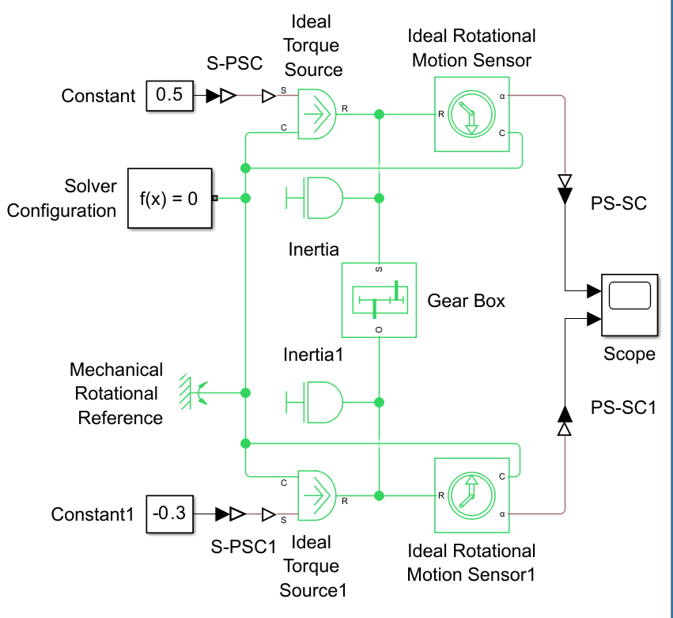

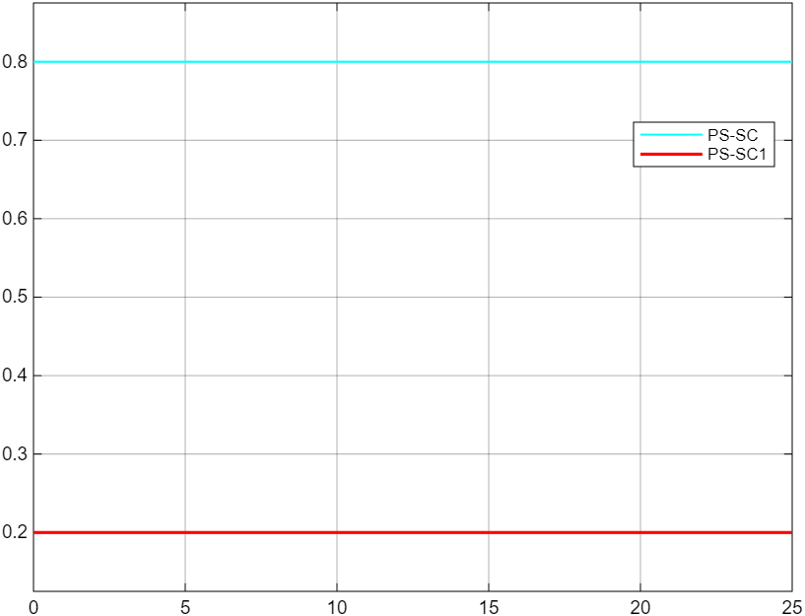

The observed acceleration values are consistent with the 4:1 gear ratio, where shaft 1 accelerates four times faster than shaft 2. The negative sign associated with J1 reflects the opposite rotational direction between the two shafts — a standard behaviour in systems with meshed gears due to the reversal of motion at the contact point.

